Ceva Drop Ship Registration

Web address: www.cevalogistics.com.

- Click “Customer tools and resources” at the top of the main page (circled in red).

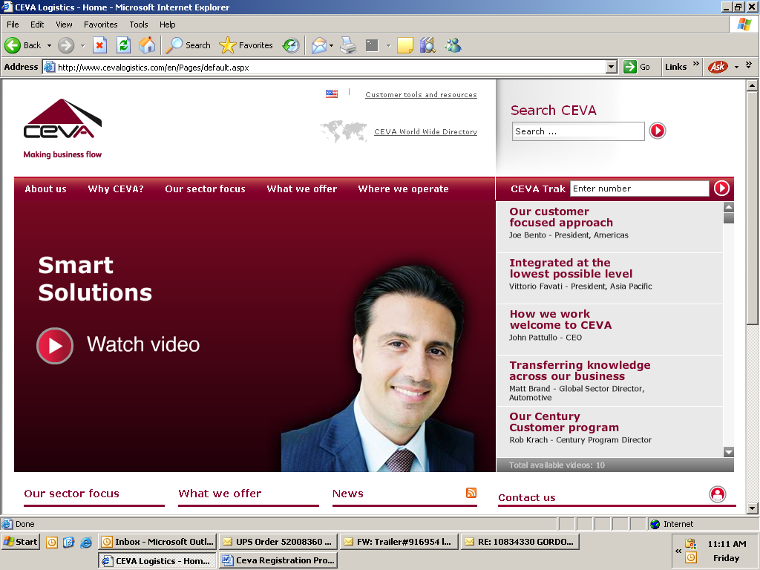
- Click on “OneView” in the drop down. (circled in red below)
  - A second window will open (Could be affected by popup blockers).
  - Enter your user id and password.

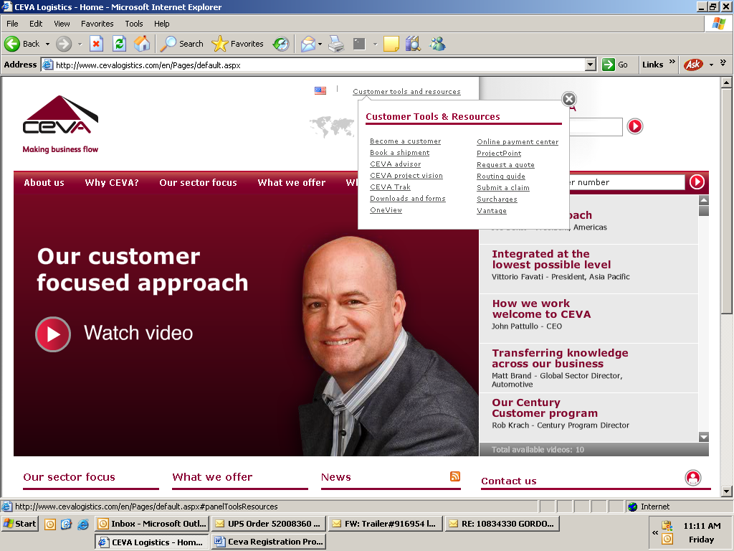

- Click on “Book” in the top tabs (circled in blue).
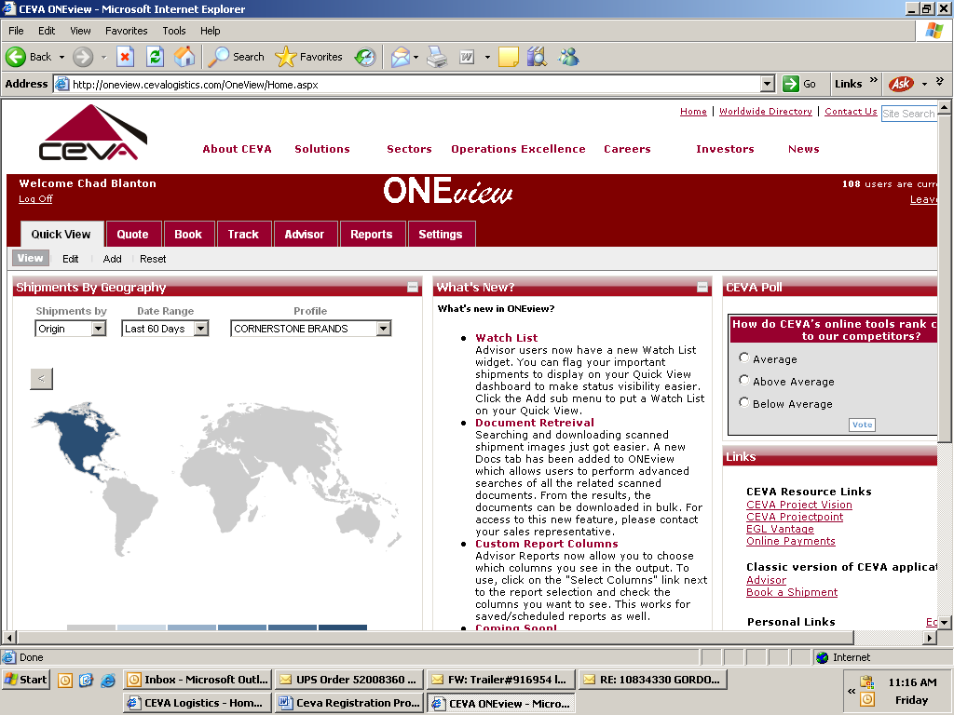

- First, enter your pickup location and contact information in the selected fields (circled in yellow):
  - If you would like to save this information for future use, you can check the box circled in red and the web site will hold this data.
- Specify a date and time when Ceva can pick up the freight from your facility (circled in green).

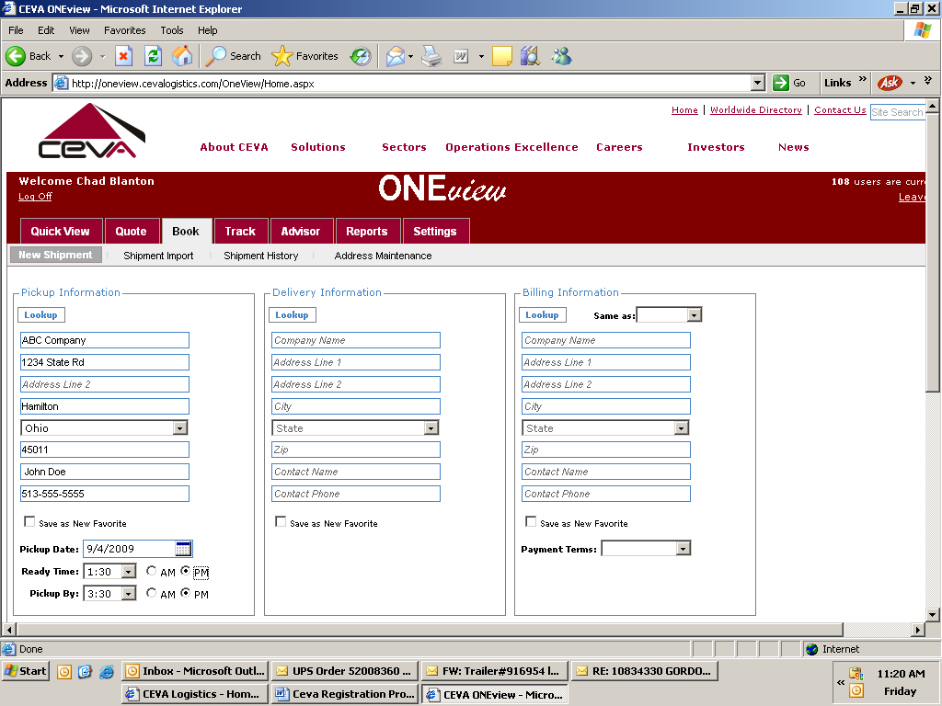

- Enter in the customer’s information (circled in red).

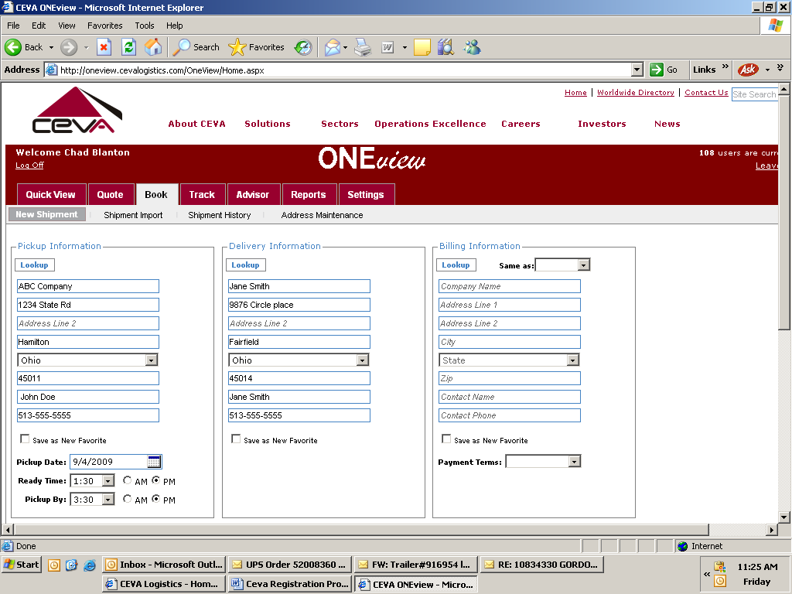

- Enter the billing information
  - Address: (circled in red)
Ballard Designs
8877 Union Centre Blvd
West Chester, OH. 45069
Cornerstone Transportation
513-603-1100
  - Select “Third Party” in the payment terms category (circled in blue).
    - Account number for Ballard Designs is BALL55450
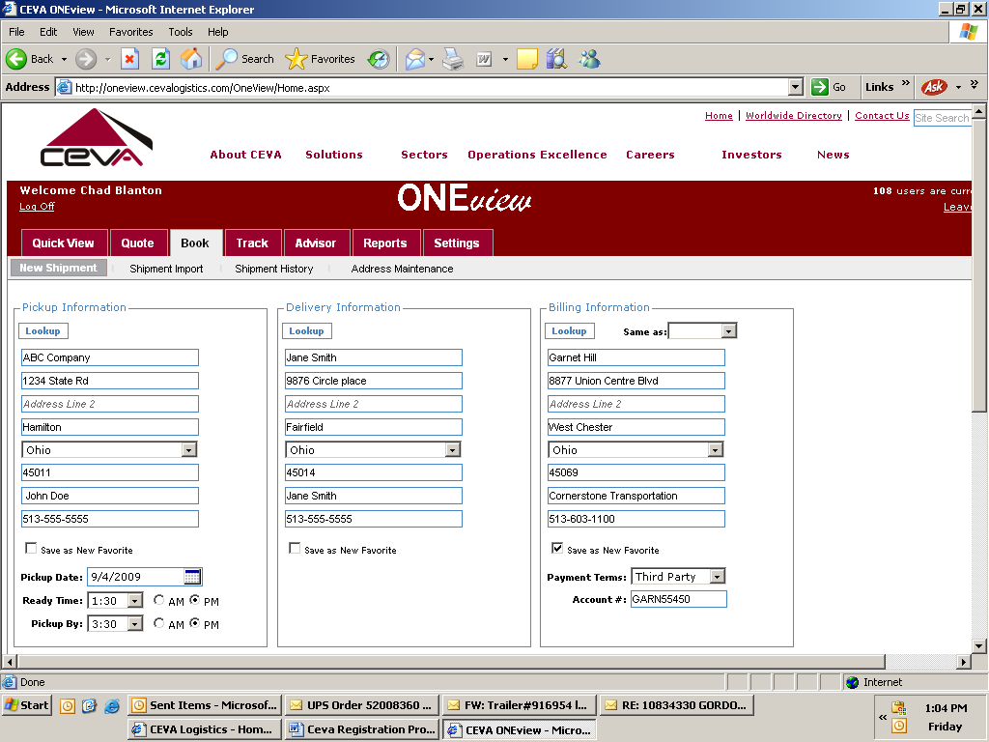

- Scroll down to the bottom of the page and enter the shipment details:
  - Enter the carton quantities, weight, dimensions and description (circled in red).
    - You’ll need to click the “+” enter each carton (circled in green).
  - Select “Purchase Order Number” under Reference Number Type (circled in blue) then enter the Ballard Designs order number (circled in yellow).

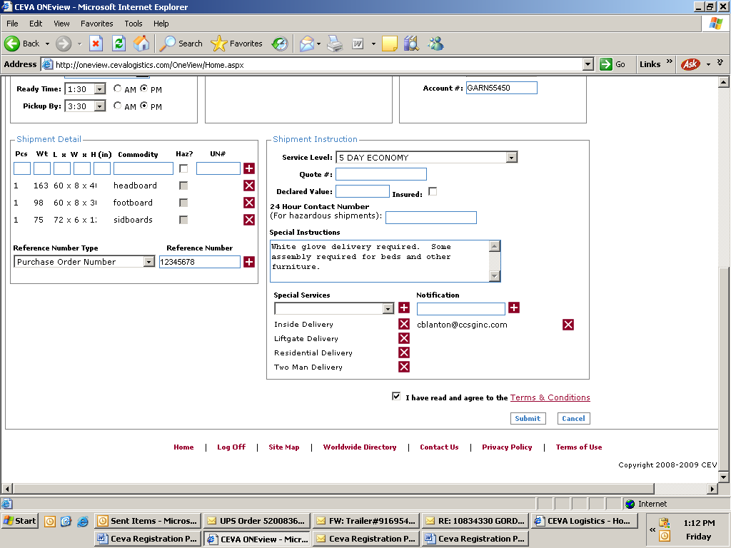

- Select “5 Day Economy” in the Service Level category (circled in blue).
- Under special instructions (circled in red) type the follow (Based on delivery service referenced on Vendor Net):
  - Threshold Service – “IDD delivery required. Contact customer service for questions.”
  - In Home Service - “WGD delivery required. Contact customer service for questions.”
- Under special service please add the following:
You’ll need to select the service from the drop down window (circled in yellow) and then click the “+” button (circled in green).
  - Inside delivery
  - Liftgate delivery
  - Residential delivery
  - 2 man delivery
- Finally, check the box for “I have read and agree to the Terms & Conditions” and click “Submit”.

- The confirmation page will give you the ability to print shipping labels and a Bill of Lading (BOL & shipping labels will open in Adobe).
  - To print at BOL simple click on the “Print Shipping Documents” (circled in blue). (You can locate your air bill/tracking number on this document).
  - To print shipping labels:
    - Select the number of labels you would like to print (red circle).
    - Select the type of printer you want to use (green circle).
    - Select the how many labels you want per page (yellow circle).
    - Click “Print Shipping Labels” (orange circle).

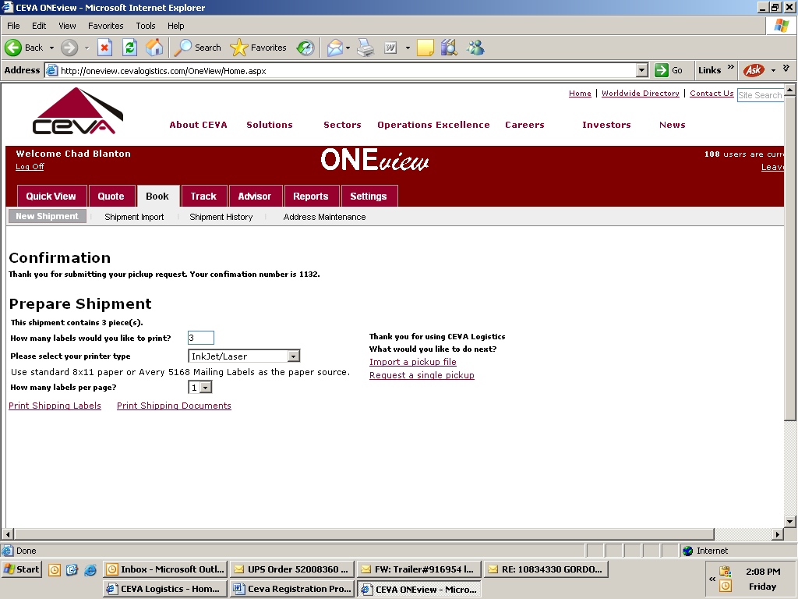

You can obtain the tracking number for the shipment (a.k.a. Air Bill # or HAWB Number) on the shipping labels or BOL. (Circled in blue)
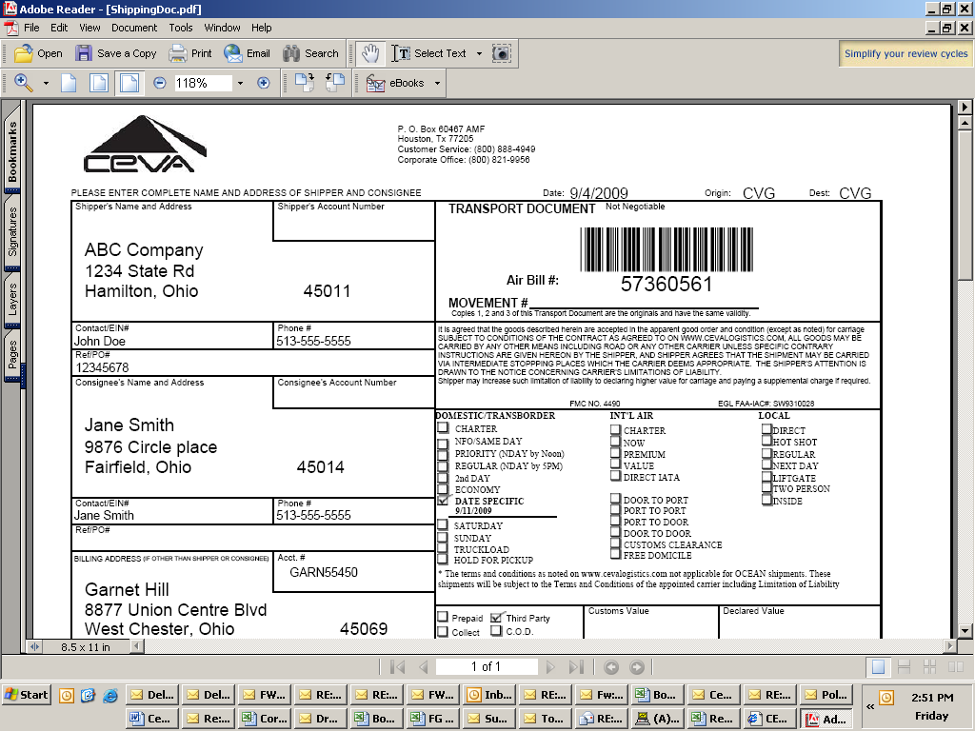
BOL

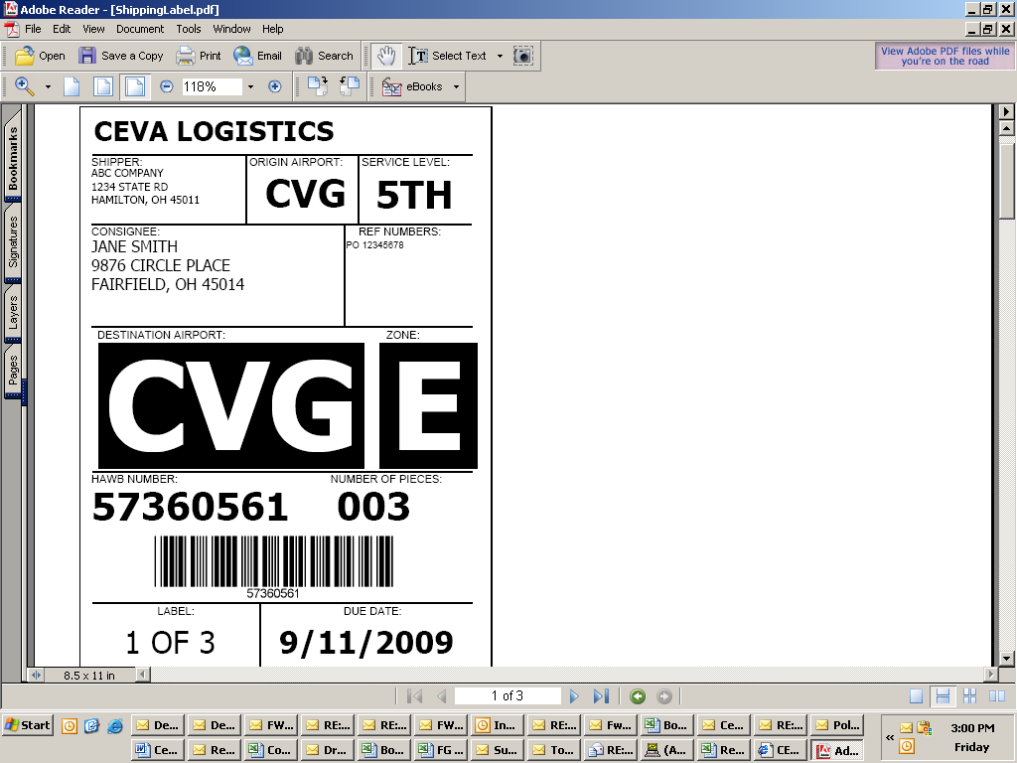
Shipping Label

